## horizontal line

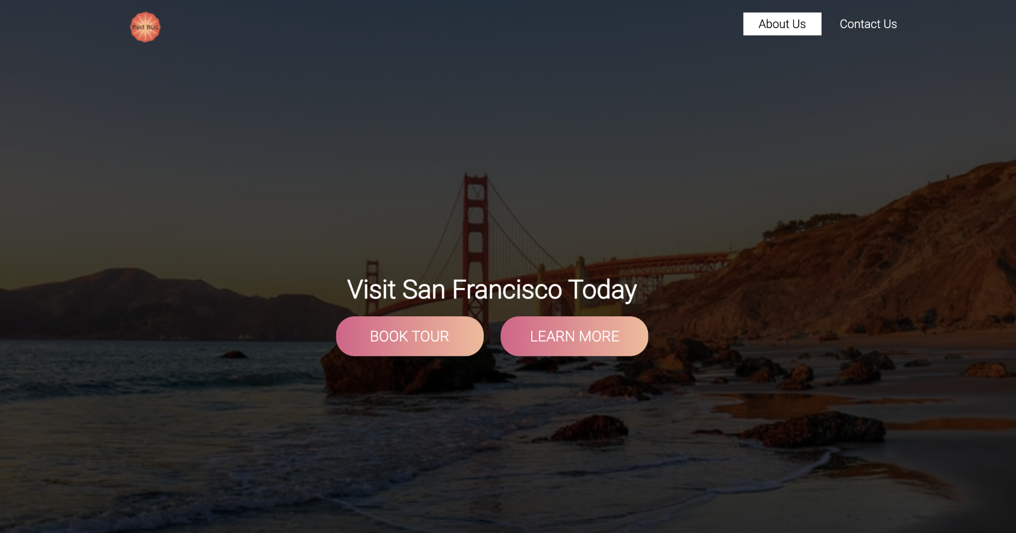

Landing Page

# Overview

For this Html - Css project, you’ll code a landing page for a fictional company. We’ll be providing a Figma design file for your reference. [Design reference](https://www.figma.com/file/Rqr8sV23Z0528vgFrX1x0f/Landing_Page?node-id=0%3A1)

This will be one of your days as a Front End Developer where you’ll receive design from the UI/UX team and your job will be to turn the design into a live website!

Don’t forget to link your Css to Html!

# Goals (Phase 1 ) The header (showcase)

1. It should have a header with a full-screen background image. Nav-bar should go on the background image.
2. To achieve a darken background image like me : you can use the following code

background-image: linear-gradient(rgba(0, 0, 0, 0.75), rgba(0, 0, 0, 0.75)), url("images/images.jpeg");

1. The header area should have your company name in the center (e.g. Welcome to Annie’s cupcakes). It should have two buttons of your choice beneath it.
2. The navbar - On the left there should be a logo. I used [This site](https://www.freelogodesign.org/) to create a free logo. If you don’t want to use the logo, you can just write the name of your company. On the right side, there should be at least two nav items, for e.g About us, Contact Us.
3. I’m giving you full flexibility to design buttons however you like and images of your choice. This [website](https://unsplash.com/) has quality images for free.
4. BONUS: One link in the navbar should be active. (search for Pseudo-elements active state.)
5. BONUS: Use hover on the links. (Pseudo-elements hover state.)

# Goals (Phase 2 ) About us (3 column layout)

1. After you’re done with the showcase area(header), follow the design and move on to the next phase: About Us.
2. In this section, you’ll add 3 images and 3 buttons under each image or one button under all images.
3. You can use the same design for buttons that you used in the showcase area. This could be achieved by using classes.
4. To achieve this, you can either use CSS grid or Css Flexbox(3 column layout).

# Goals (Phase 3 )

1. Footer- The footer should include the contributors’ names with their LinkedIn/Github links.
2. Finally, it should have your fictional company's social media icons. Like, follow us on Twitter, Linkedin.
3. Use Font Awesome in the Footer to get icons for LinkedIn and Twitter. I found [this website](https://www.w3schools.com/icons/icons_reference.asp) useful for font awesome.
4. Make it more interactive! Add hover effects.

# Goals (Phase 4 ) BONUS

1. Deploy and share the link in the student’s slack channel :)
2. Finish designing the form that I put in the design.

# Good Practices and Requirements

## Indent Your code and Write comments where necessary *

## Use Google Fonts (Robato or Poppins are trending) *

1. The design is there just to guide you. The images and content you can personalize.
2. Project structure -
   * + 1. make a directory Landing_Page inside Dev
       2. Cd into it.
       3. Create an index.html
       4. Create another directory Css.
       5. Inside the Css directory, create style.css and a directory to store images. You can call it images.
       6. You can use a terminal to create these files and folders or use VS Code.

Have fun and Happy Coding!!!